COMPUTER SCIENCE 378: INTRODUCTION TO DATABASE MANAGEMENT
Assignment 2
Jackson Wiebe
3519635
Total: 100 marks
Weight: 15% of your final grade
Due: After you have completed Unit 6.
Answer all of the following questions, and upload your completed work here.

Question 1 (12 marks)
Consider the following EER diagram for the Royal Victoria Hospital (RVH) database.
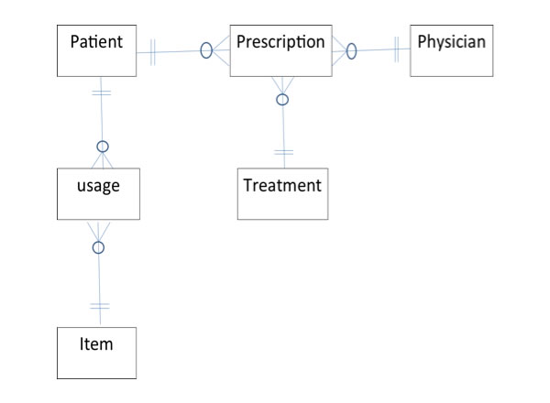
Data volume and access for this diagram are as follows:
- There are 1 000 patients and 500 items yielding a total of 10 000 usage records in the database.
- There are 50 physicians and a total of 4 000 prescriptions in the database.
- There are 200 treatments in the database.
- There are 50 accesses per day for patient records; of these, 30 request access to both prescription and usage records.
- There are 20 accesses per day for physician records; of these, 20 request access to prescriptions.
- There are 50 accesses per day to item records; of these, 10 request access to usage records.
- There are 5 direct accesses per day for treatment records.
- Of the total accesses to prescription records, 20 request access to patients, 30 request access to physicians, and 35 request access to treatment.
- Of the total accesses to usage records, 10 request access to patients and 30 request access to items.
Draw a composite usage map for the RVH database.

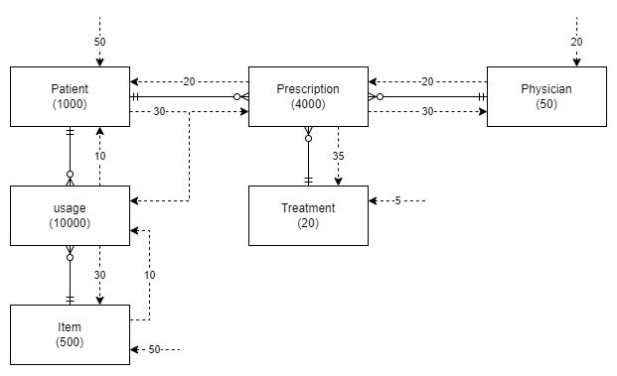

Question 2 (15 marks)
Answer the following questions (250 words max/question).
- What are the typical integrity controls performed in both data integrity and referential integrity?
Default value: When set to the default value we can expect the value will maintain our set references and not fault the data integrity.
Range control: Only allowing data inside a specific range. Thus we will not exceed the data type and our references know what range to expect. For instance forcing a uint32_t variable for UNIX time.
- Using an example for each situation, illustrate the three common situations that suggest relations should be denormalized.
Two entities with a one-to-one relationship. While we can normalize the data into a one to one relationship it may not be necessary for faster access of the data. “Single sign-on” systems take advantage of this by allowing application to share user details and simplify the login process with a unified table of users. Thusly the backend service does not need to keep a secondary cope of the user data.
A many-to-many relationship (associative entity) with non-key attributes. When using an intermediary relation to link 2 or more items that do not share the same key. It may be possible to directly link the 2 objects by adding the primary key to the secondary object. If we have a Vendor Bob (VendorID 42) who sells us Item Paint Z ( ItemID 66). We can eliminate the intermediary relation by storing our VendorID with the Item. Or visa versa.
Reference data. Where you are using a secondary table to store a few pieces of simple data that can be combined with the parent table. Reference data can be carried into the parent table and the link can be eliminated. This could be information like an objects color or physical storage location. If we have our Paint Z ( ItemID 66) which links to an MSDS_Sheet, we could directly store the MSDS link in the itemID object.
- What are the advantages and disadvantages of horizontal and vertical partitioning?
Horizontal Partitioning:
Tables are wider and each record contains more data. Records are split among the databases that need the specific data.
+ Efficiency. Number of records can be kept shorter by only records relevant to that datacentre.
+ Ease of Query. The data is simple and already joined with the most commonly requested data.
- Speed. When queries need to span several databases it can be quite slow.
- Backup. Without explicit replications data can be more vulnerable should a single table get destroyed.

Vertical Partitioning:
Tables are siloed into the required data sets. Columns of information are split out to the relevant silo.
+ Efficiency. Only the relent data is kept at that site. We do not need to store all records of a product, just those relevant to production or sales.
- Speed. When queries need to span several databases it can be quite slow.
- Backup. Without explicit replications data can be more vulnerable should a single table get destroyed.

Question 3 (15 marks)
Answer the following questions (250 words max/question).
- What factors should be considered when choosing a file organization?
- Storage space
- Sequential versus random key retrieval
- Multi-key retrieval
- Deleting
- Addition
- Updating
- What is the purpose of clustering data in a file?
We can increase the speed of retrieval where data can be clustered into like types. Frequently accessed static data can be clustered together with the assumption that data set is going to be frequently accessed together.
- Compare hashed file organization versus indexed file organization. List two advantages of indexed over hashed, and two advantages of hashed over indexed.
Index lookup provides the advantage of an array or linked list for fast lookup, we know that information X is stored after information F. Since the storage boxes are sudo fixed we can quickly lookup multiple objects without running a hash algorithm. Sequential lookup are very easy since we only need to move our pointer to the next item in the chain.
Hash indexing has the advantage for deleting records since we only need to lookup the index and erase, there are no links / double links to maintain. Its also faster for updating records since again there are no links to maintain. Hash indexing however suffers greatly when trying to perform a sequential lookup since reversing a Hash is not intended to be easy.

Question 4 (18 marks)
Consider the following database:
Employee(emp-no, name, department, salary), ProjAssigned(emp-no, proj-no, worked-hours)
- Write one SELECT SQL query to list the numbers and names of all employees with a salary greater than 66 000 who are assigned to projects, the projects they are assigned to, and the corresponding hours worked. Your list should be sorted by employee name.
SELECT Employee.emp-no, Employee.name, ProjAssigned.proj-no, ProjAssigned.worked-hours
FROM Employee
INNER JOIN ProjAssigned ON Employee.emp-no = ProjAssigned.emp-no
WHERE Employee.salary > 66000
AND ProjAssigned.proj-no IS NOT NULL
ORDER BY Employee.name ASC;
- Define indexes on selected attributes to speed up your query, and justify your selections.
For this query we are filtering data based on the Employee Salary and if that employee is assigned to a project. Therefor creating indexes for those values would help pre-select the targeted data.
Since we are returning all employee names and employee numbers that fit the requirements and not filtering. Indexing the employee names and numbers are not going to help here.
- Write SQL queries to create the indexes you defined above.
CREATE INDEX emp-sal-idx
ON Employee (salary);

CREATE INDEX emp-pro-idx
ON ProjAssigned (proj-no);

Question 5 (40 marks)
Consider the following three relations:
TRAVEL_AGENT (name, age, salary)
CUSTOMER (name, departure_city, destination, journey_class)
TRANSACTION (number, cust_name, travel_agent_name, amount_paid)
Assume that the attribute “name” in the relations TRAVEL_AGENT and CUSTOMER is a unique identifier (i.e. a string that concatenates ID number, first name, and last name).
Write SQL statements to answer the following questions.
- Compute the number of different customers who have a transaction.
SELECT COUNT ( DISTINCT cust_name)
FROM TRANSACTION;
- Display the name of the oldest travel agent.
SELECT name
FROM TRAVEL_AGENT
ORDER BY age DESC
LIMIT 1;
- List the total number of transactions for each travel agent. Consider only those transactions where the amount paid exceeds 1 000.
SELECT travel_agent_name, COUNT (number)
FROM TRANSACTION
WHERE TRANSACTION.amount_paid > 1000
GROUP BY travel_agent_name;
- Display the names and ages of the travel agents who have arranged journeys for customer “John Smith”, in descending order of age (use a subquery).
SELECT name, age
FROM TRAVEL_AGENT
JOIN (SELECT cust_name, travel_agent_name
FROM TRANSACTION
WHERE cust_name LIKE '%John Smith') sub
ON TRAVEL_AGENT.name = sub.travel_agent_name
ORDER BY age DESC;

- Display the names and ages of travel agents who have arranged journeys for customer “John Smith”, in descending order of age (do not use a subquery).
SELECT name, age
FROM TRAVEL_AGENT
INNER JOIN TRANSACTION ON TRAVEL_AGENT.name=TRANSACTION.travel_agent_name
WHERE cust_name LIKE '%John Smith'
ORDER BY age DESC;
- Display the age of travel agents who have arranged journeys for customer “John Smith” to “Ottawa” (use a subquery).
Stuck here.. How to use subquery for multiple tables?
- Display the age of travel agents who have arranged journeys for customer “John Smith” to “Ottawa” (do not use a subquery).
SELECT age
FROM TRAVEL_AGENT
INNER JOIN TRANSACTION ON TRANSACTION.travel_agent_name = name
INNER JOIN CUSTOMER ON CUSTOMER.name = TRANSACTION.cust_name
WHERE cust_name LIKE '%John Smith'
AND destination LIKE 'Ottawa';
- Display the names and salaries of all travel agents who did not arrange journeys for customer “John Smith”, in ascending order of salary.
SELECT name, salary
FROM TRAVEL_AGENT
INNER JOIN TRANSACTION ON TRANSACTION.travel_agent_name = name
WHERE cust_name NOT LIKE '%John Smith'
ORDER BY salary ASC;
- Display the names of travel agents who have five or more transactions.
SELECT travel_agent_name, COUNT (travel_agent_name) as count
FROM TRANSACTION
GROUP BY travel_agent_name
HAVING COUNT >= 5;

- Display the names of all travel agents who have arranged at least ten journeys to “Ottawa”.
SELECT name
FROM TRAVEL_AGENT
INNER JOIN TRANSACTION ON TRANSACTION.travel_agent_name = name
INNER JOIN CUSTOMER ON CUSTOMER.name = cust_name
WHERE destination LIKE 'Ottawa'
GROUP BY travel_agent_name
HAVING COUNT(travel_agent_name) >= 1;

